Competitive Shooters of Lake Norman USPSA December 11th, 2025
COURSE DESIGNER: Ryan Christenson
START POSITION: See written stage briefings.

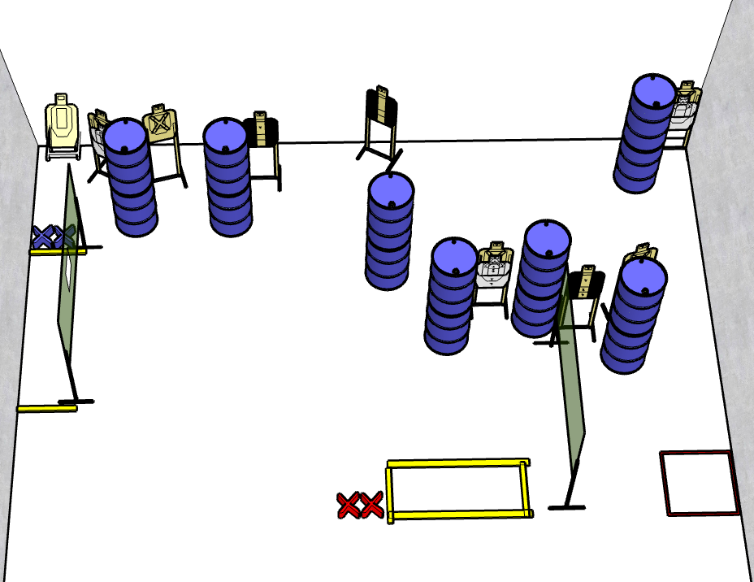

Written Stage Briefing:

Stage 2 - The dog must have ate it

Rounds - 18-rounds
Points - 90 points
Targets - 9 cardboard targets and some noshoots.
Scoring: Virginia Count
Open targets – best 3 hits score
Tux targets – best 2 hits score
NS Partial targets – best 1 hit scores
Handgun start position Both feet on red X’s. The handgun is loaded and holstered.
PCC start position Both feet on red X’s. PCC is loaded with stock touching belt.
Procedure: On the audible start signal, engage targets from within the shooting area.

